ICP (Elionix EIS 700) 簡介
- 儀器全名：電感耦合電漿蝕刻系統 (Inductively Coupled Plasma Etching System 型號：EIS-700)
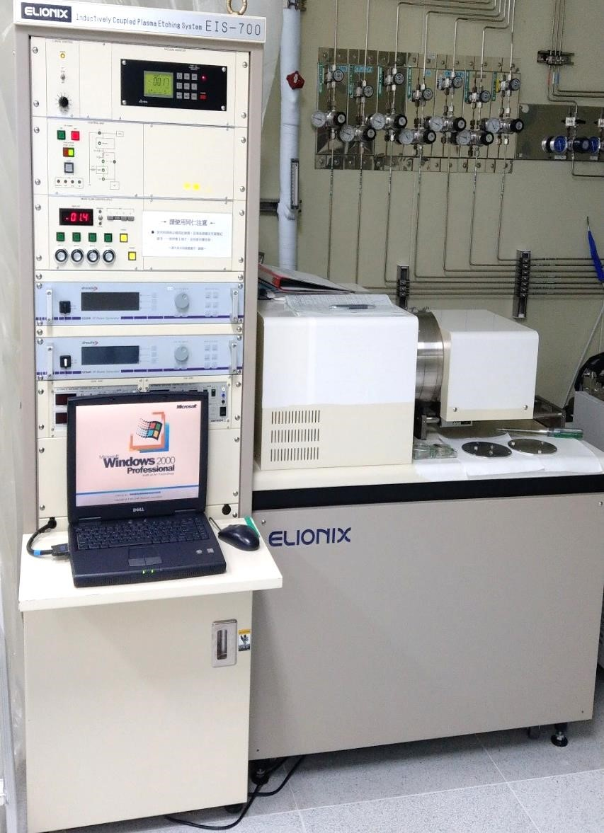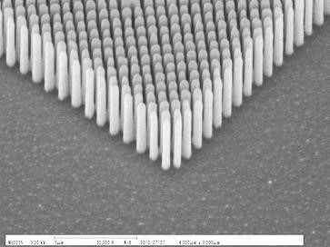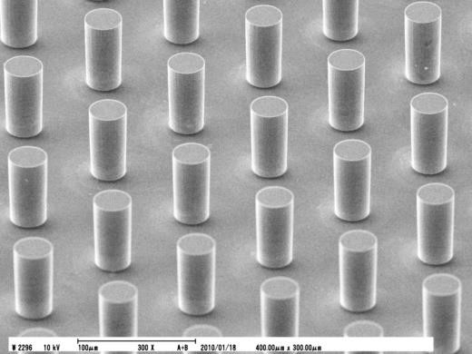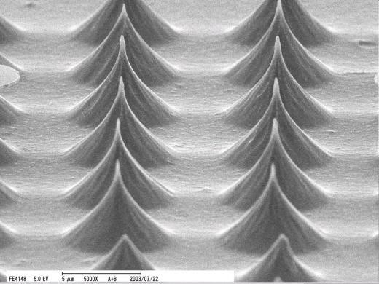

Elionix

Elionix

Elionix

- 服務簡介：
EIS-700 具可程式化與配有1 KW高頻輸出電壓進行蝕刻製程。本機台配有Ar, O2, C4F8, SF6四種氣體，所有蝕刻參數步驟可經由電腦自動化控制；EIS-700可達到良好的蝕刻準直性，以更短時間取得較高或較深的結構。
- 儀器規格：
Sample size | Max to 6 inch wafer
High frequency power supply | 1 KW (Max)
Bias power supply | 300 W (Max)
Gas flow | Ar, O2, C4F8, SF6
- 收費標準：
尖峰時間(9am-19pm)：1,500 NTD/2hr 離峰時間(19pm-9am)：1,000 NTD/2hr
1

ICP (Elionix EIS 700)
- MODEL：Elionix EIS-700 Inductively Coupled Plasma Etching System

Elionix

Elionix

Elionix

- Introduction：
EIS-700 is equipped with programming function for etching and 1 KW high frequency output for good producibility. All etching process can be operated automatically by CPU control, supplying Ar, O2, C4F8, SF6 gas flow for fluorine etching process.EIS-700 can achieve excellent anisotropic etching characteristic compatible with high aspect cross-sectional shape for high speed application.
- Spec：
Sample size | Max to 6 inch wafer
High frequency power supply | 1 KW (Max)
Bias power supply | 300 W (Max)
Gas flow | Ar, O2, C4F8, SF6
- Chargement：
Rush Hour(9am-19pm)：1,500 NTD/2hr
Off-peak(19pm-9am)：1,000 NTD/2hr
2

